Chapter 5 - Array Data structure

Arr[] = {10,20,30,20}

Elements are stored at contiguous memory location.

Array elements are generally accessed using index. Mostly begin with 0

Adv: Random access - We can get elements using O(1)

Cache friendliness - Cache is a memory closest to CPU, ideally we want program to be in cache. It is the fastest

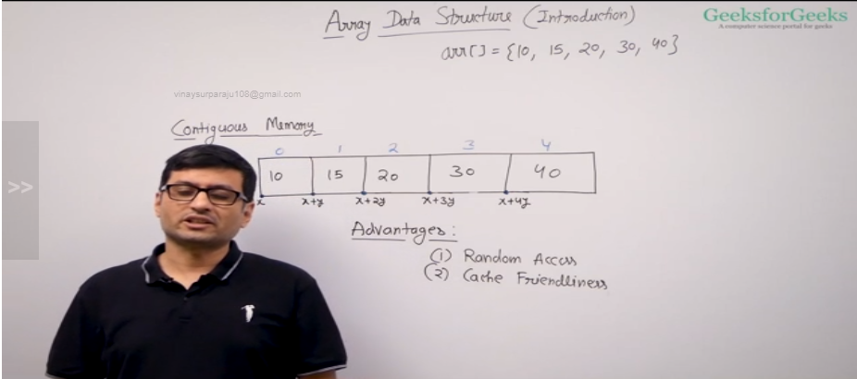

Array types:

1. Fixed sized arrays
2. Dynamic sized arrays

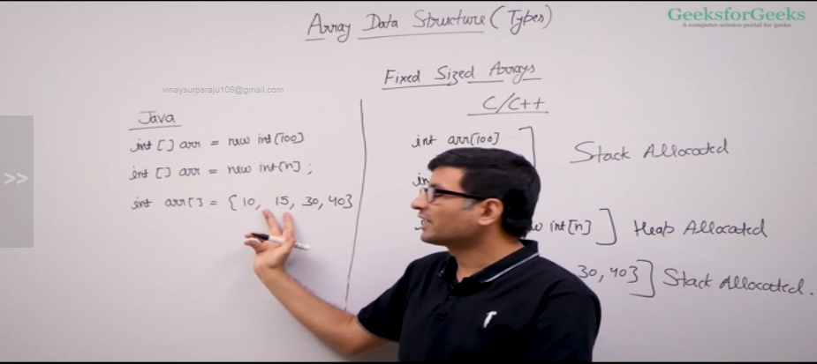

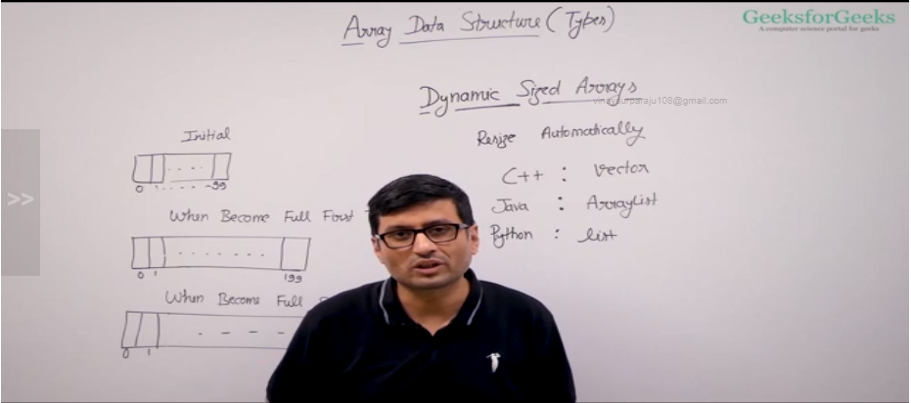

Recommended to use dynamic sized arrays over fixed size arrays- it can act as fixed size array and when required can increase the size dynamically. It also has inbuilt methods for insertion, deletion etc

ArrayList :

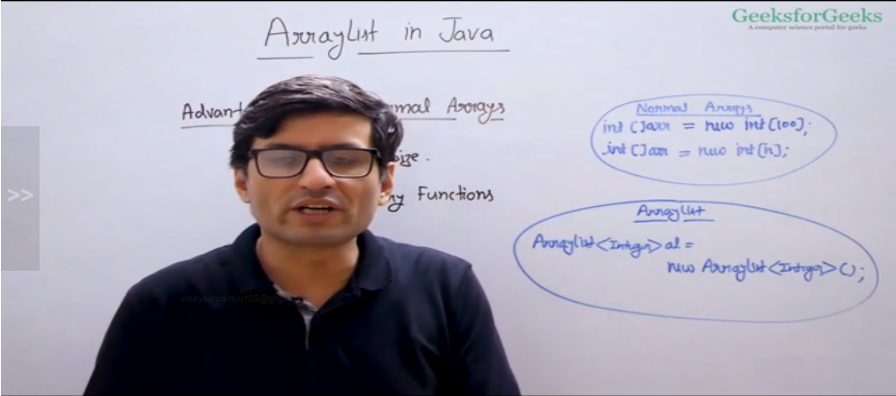

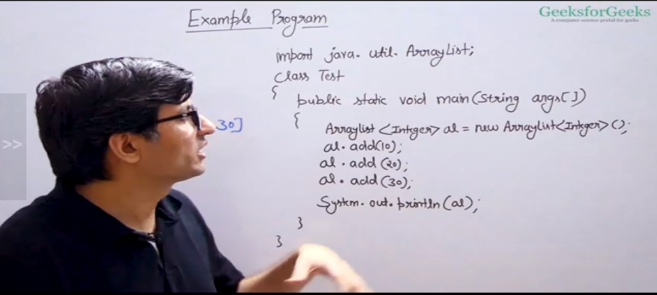

Operations in Array:

Unsorted array search: Time complexity is O(n) I.e., it will traverse the whole array and return -1 using linear search

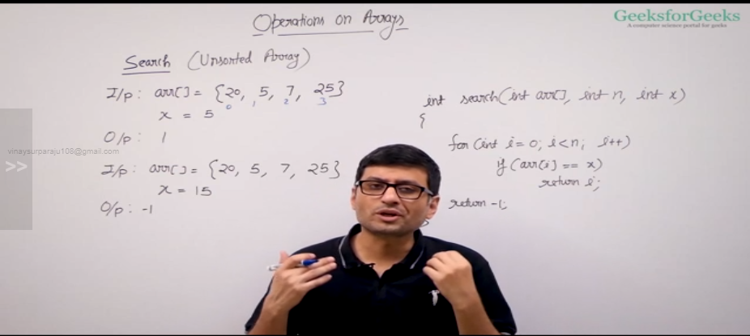

Time complexity for sorted array will be O(logn) using binary search

Insert operation for fixed size array:

We cannot insert element in fixed size array if it is already full

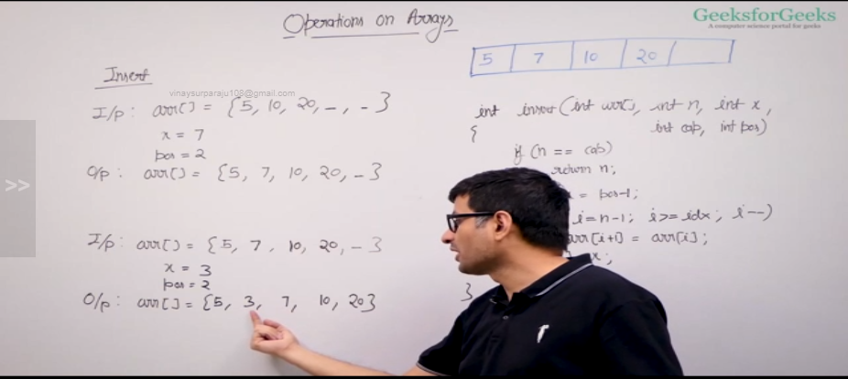

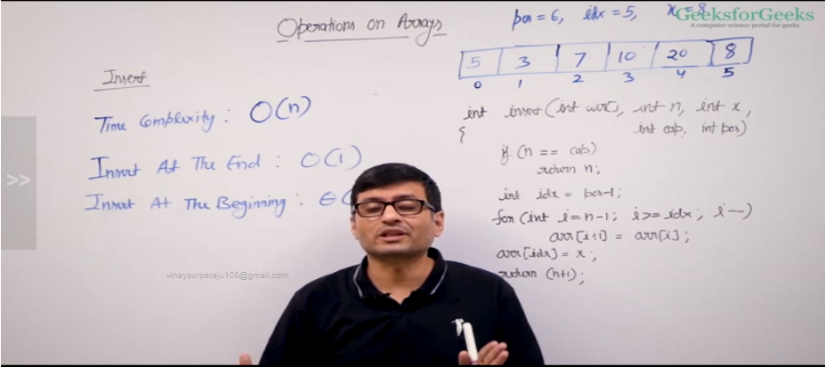

Insert operation in dynamic sized array:

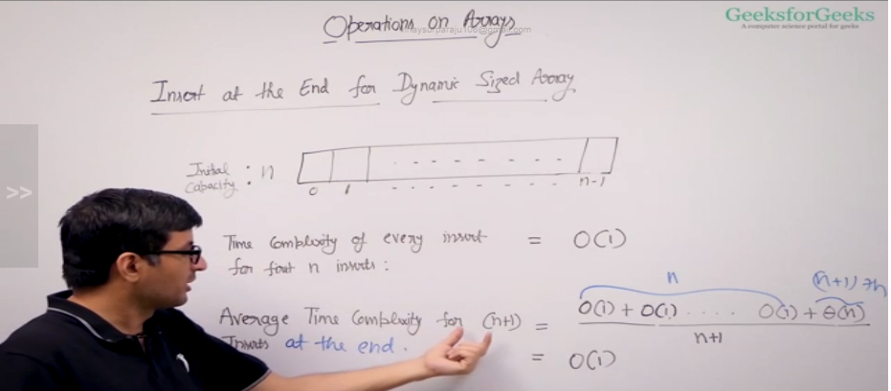

Delete operation in array:

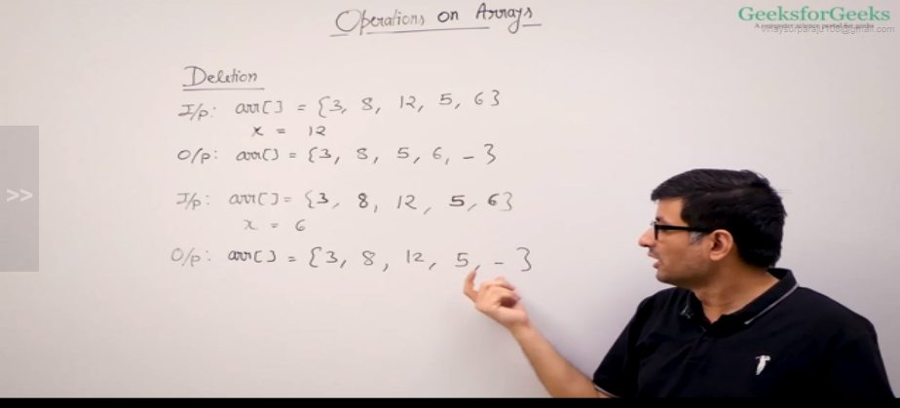

Time complexity is O(n)

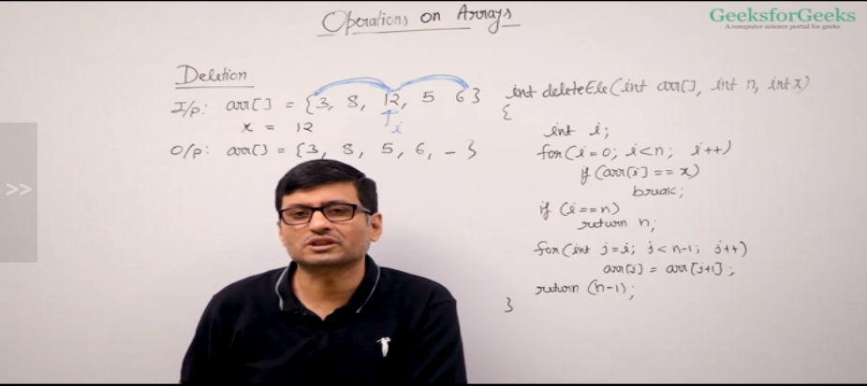

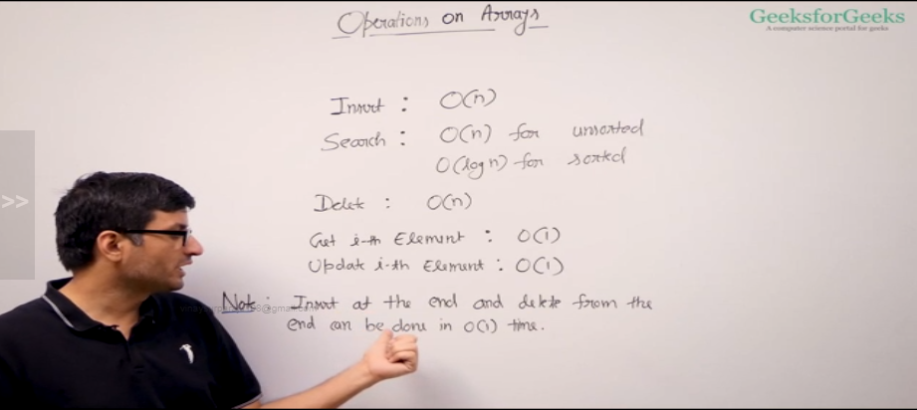

Hashing has better time complexity for insert,search and delete

Largest element in an array:

Naive sol: Time complexity is O(n\*n)

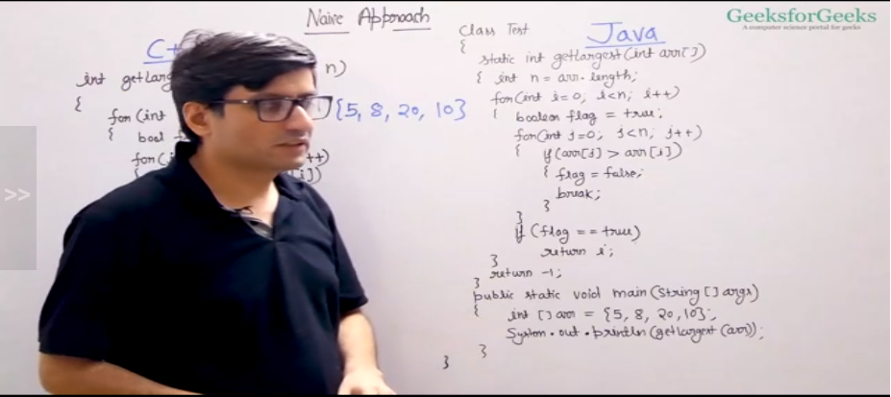

Efficient approach:

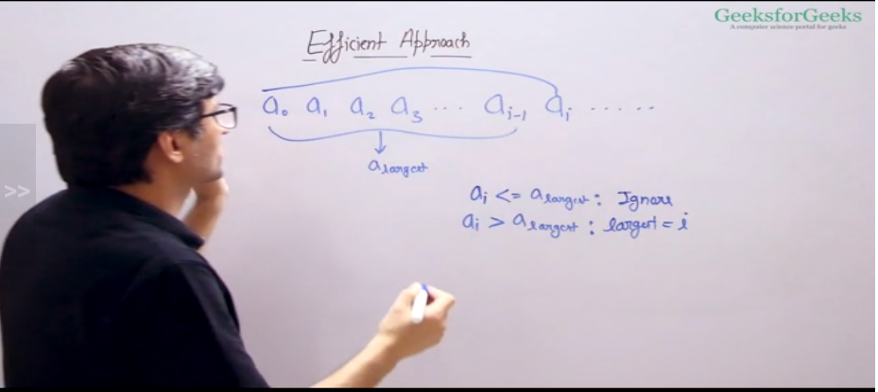

Time complexity is O(n)

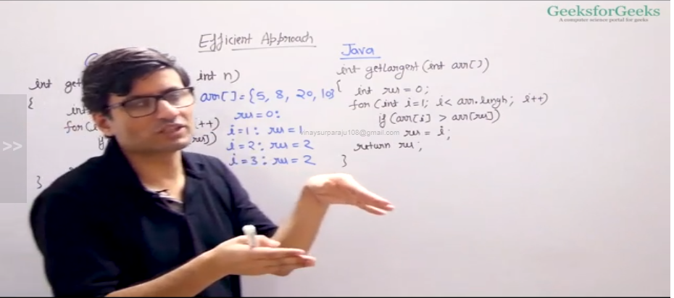

Second largest element:

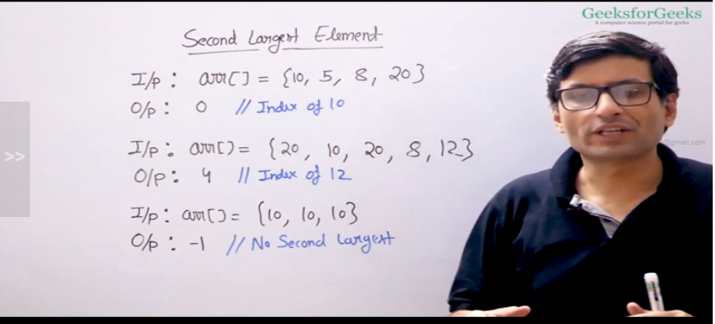

Naive approach: Time comp is O(n) but has two traversals

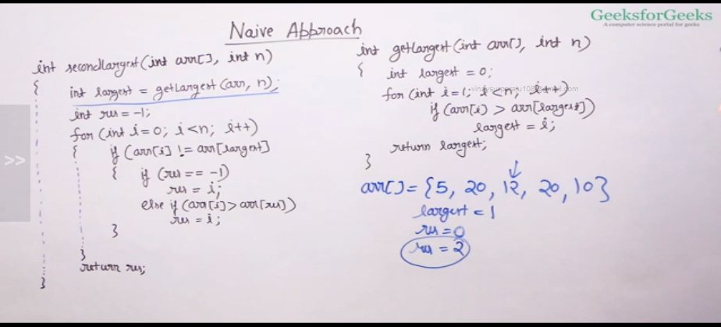

Efficient approach: to have a single traversal

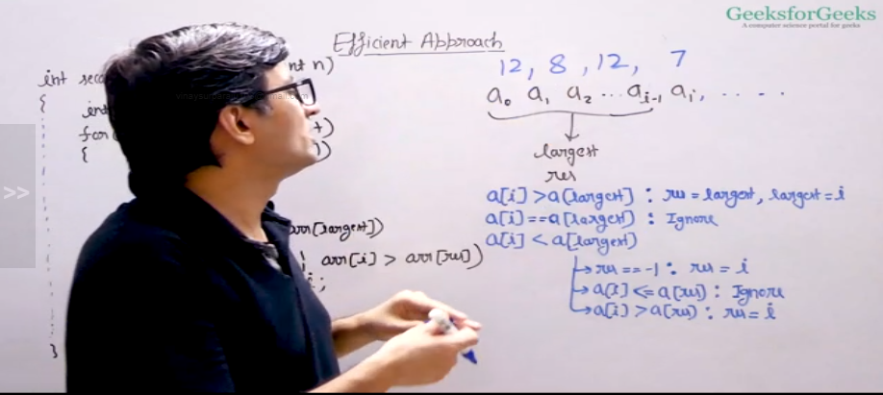

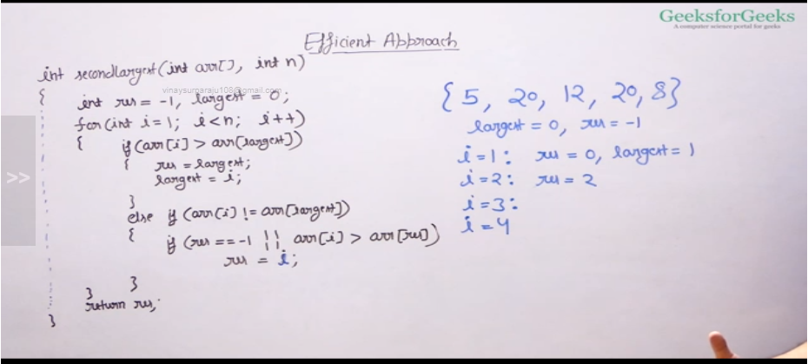

To check if array is sorted: We are checking for values in array in increasing order

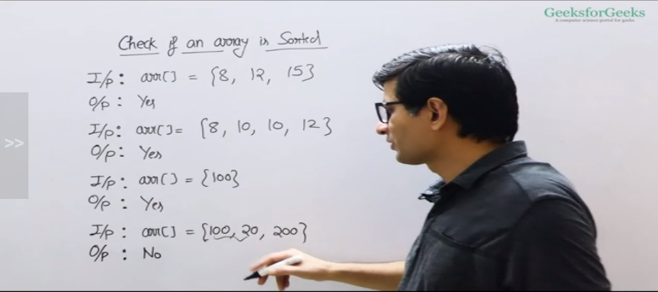

Naive method:Time complexity is O(n\*n)

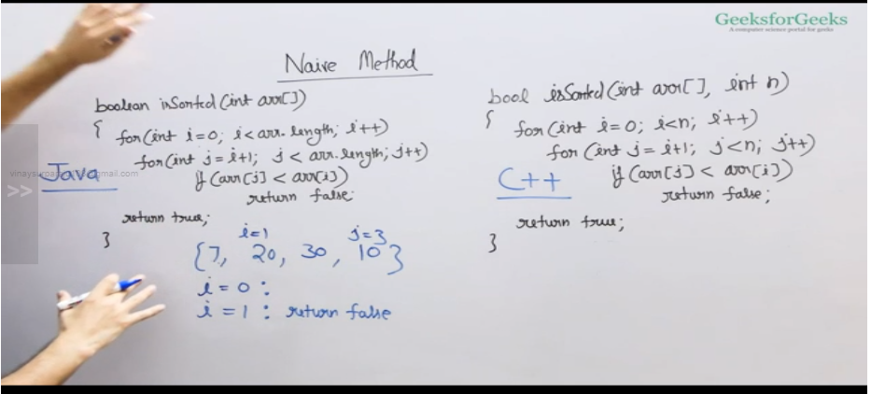

Efficient approach: Time complexity is O(n)

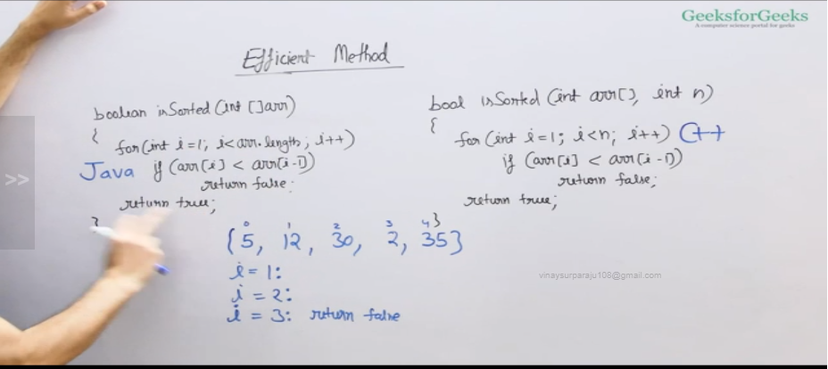

Reverse an array: Time comp is theta(n) and aux space is theta(1)

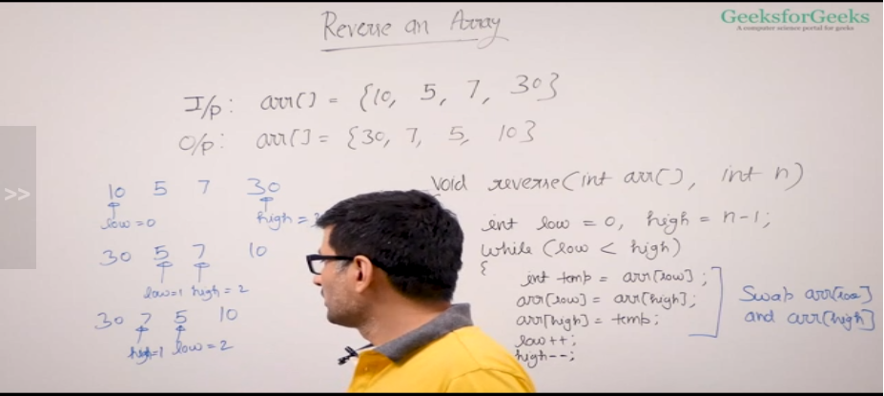

Remove duplicates from an sorted array:

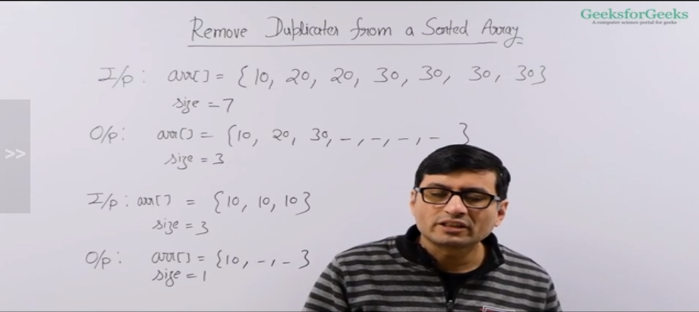

Naive approach:

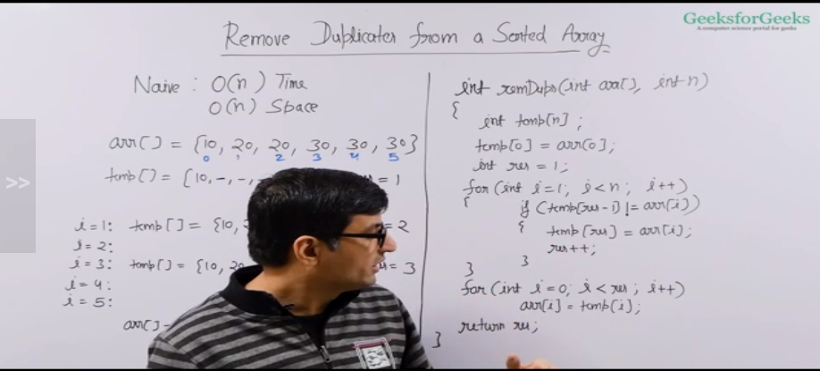

Efficient approach:

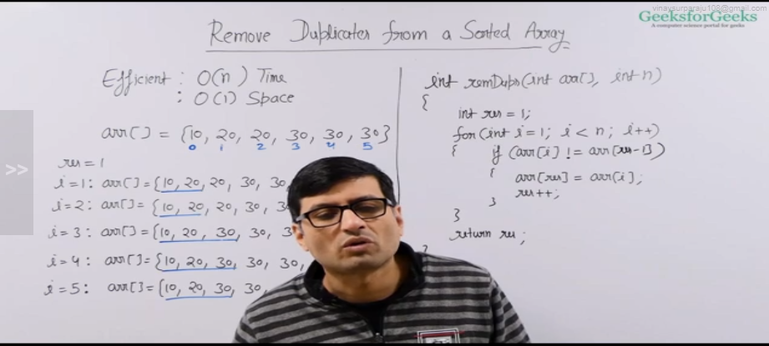

Move zeroes to end:

Naive sol:

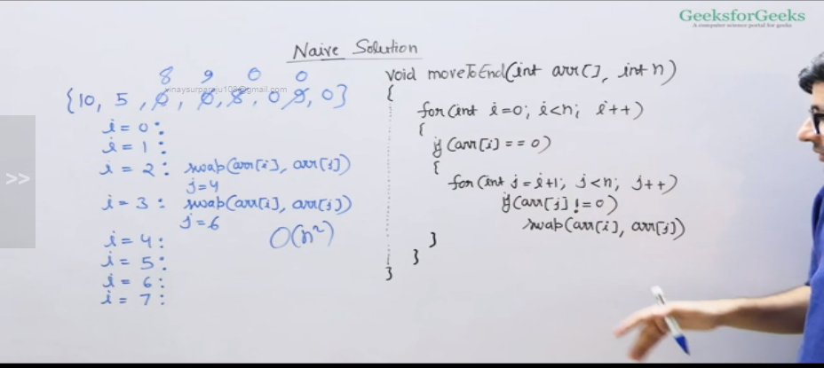

Efficient approach: Time comp is O(n) and space comp is O(1)

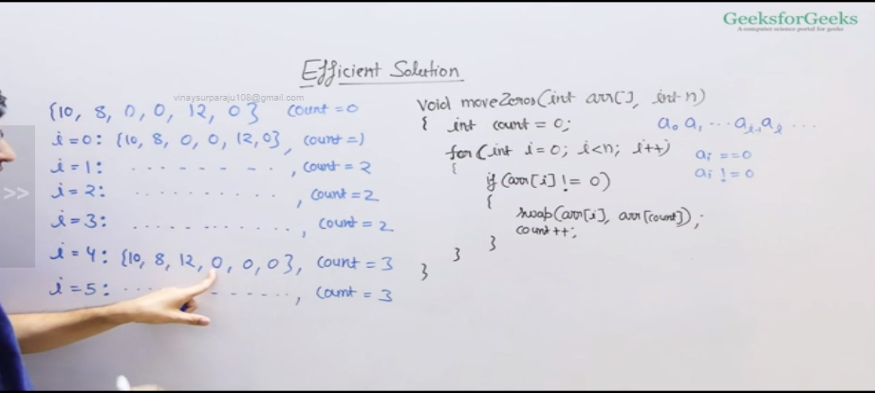

Left rotate and array by 1: Time compl is theta(n) and theta(1) aux space

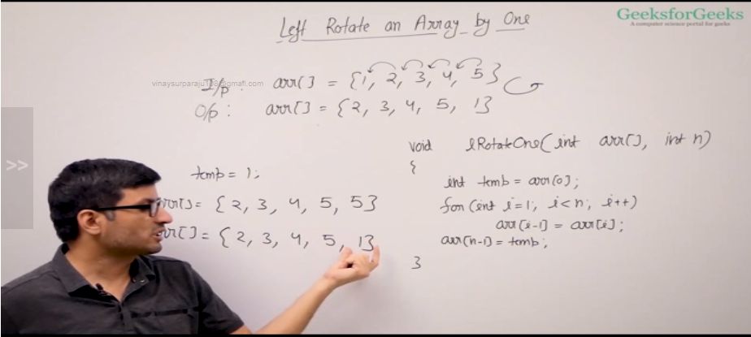

Left rotate array by D values:

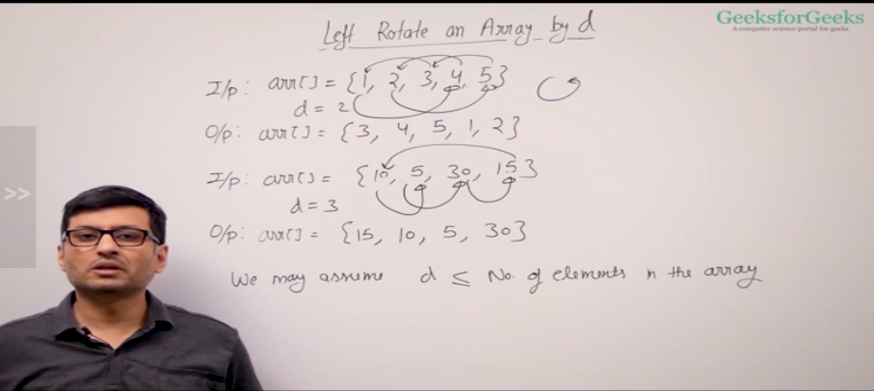

Naive sol:

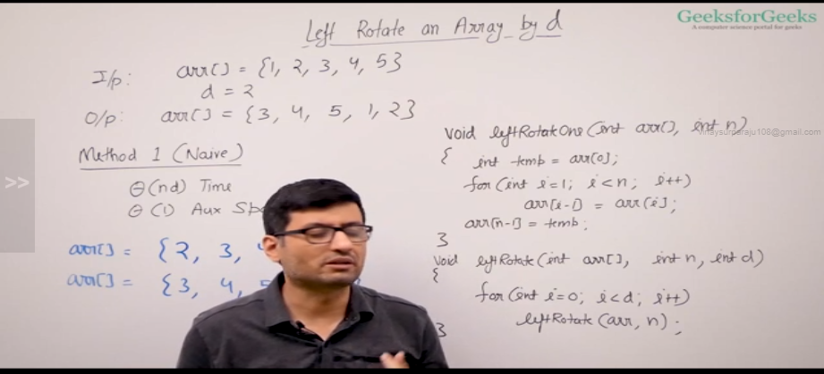

Better approach:

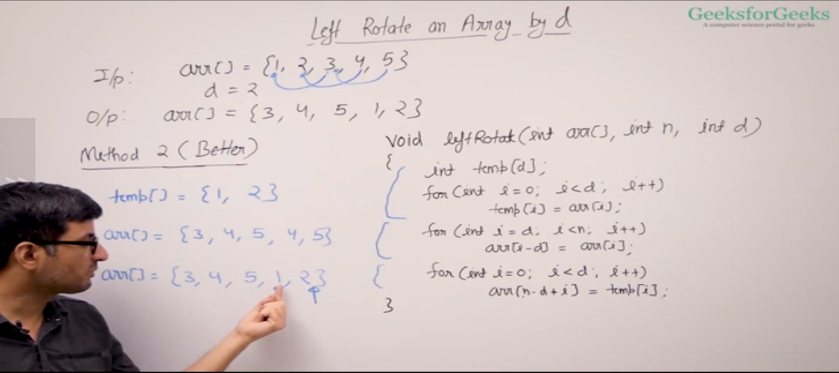

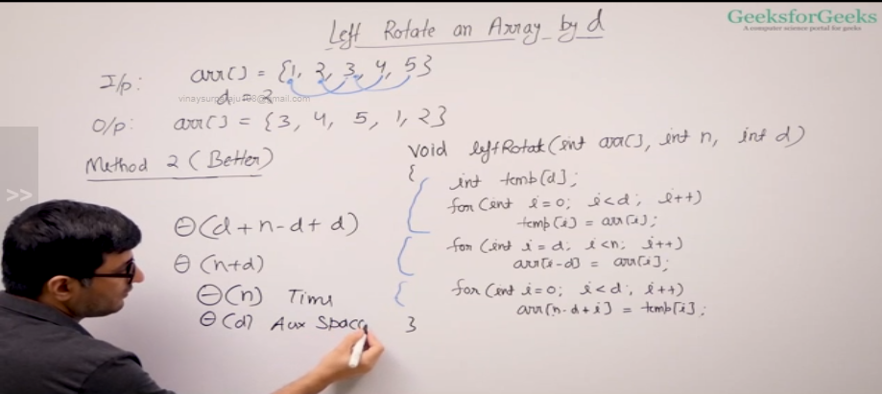

Reversal algorithm:

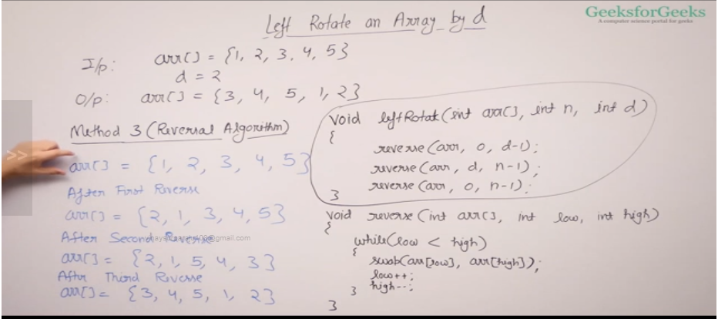

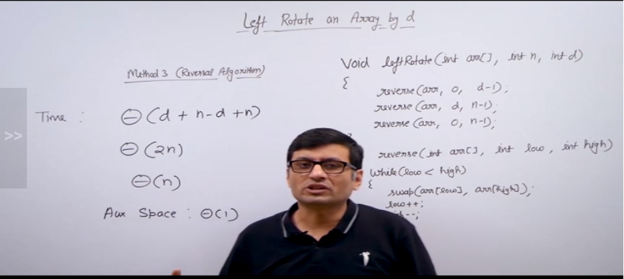

Leaders in an array:

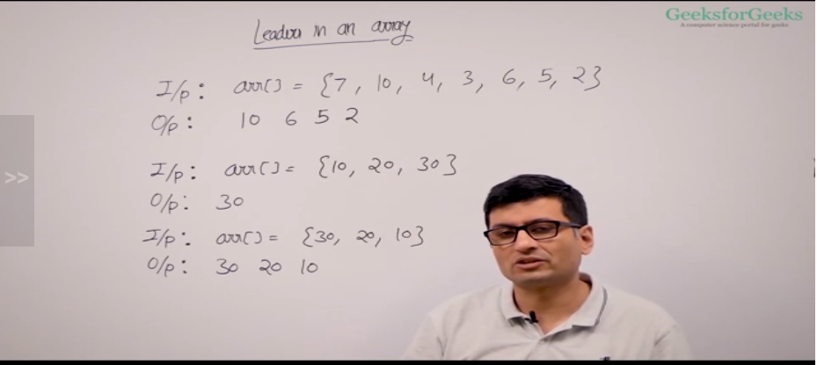

Naive sol:

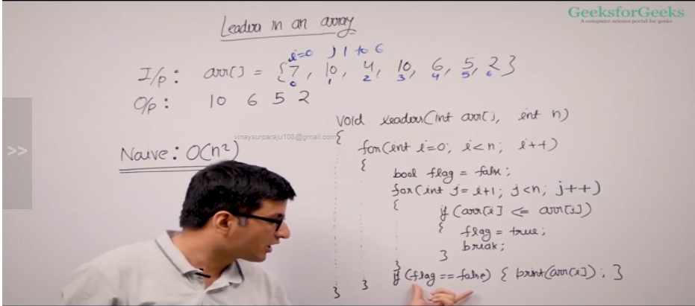

Efficient app:Time comp is theta(n)

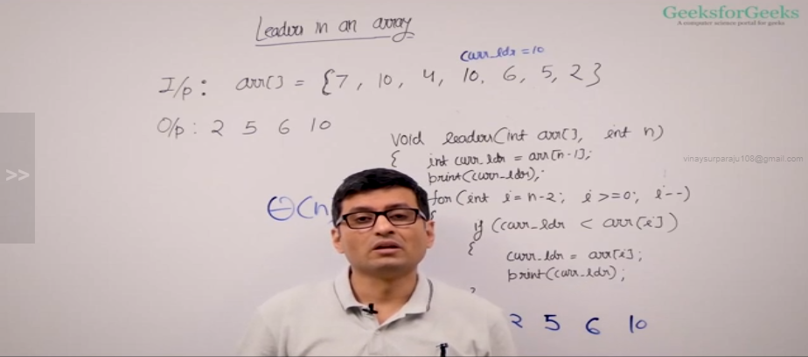

Maximum difference in array: In a sorted array max difference is bw last and first element

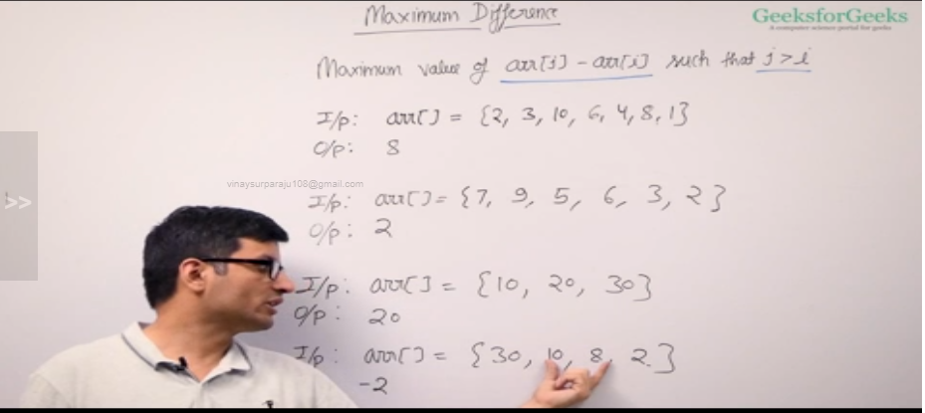

Naive approach: time complexity is theta(n^2)

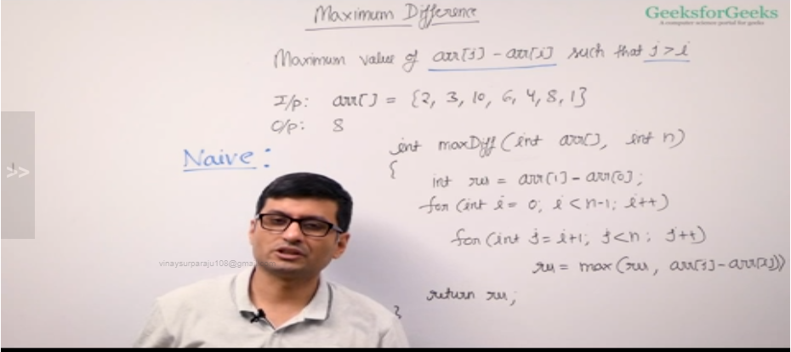

Efficient app: Time comp is theta(n) and requires theta(1) aux space

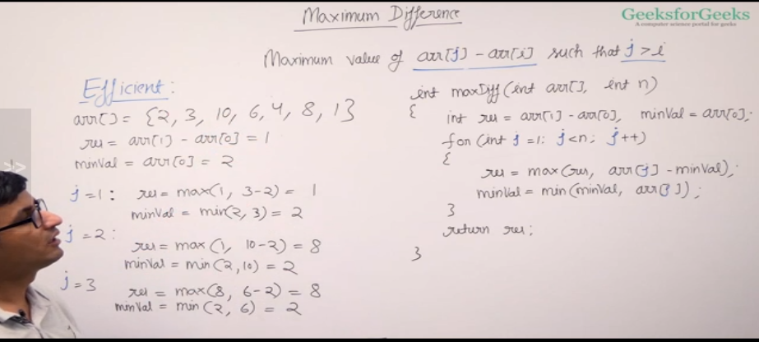

Frequency in sorted array:

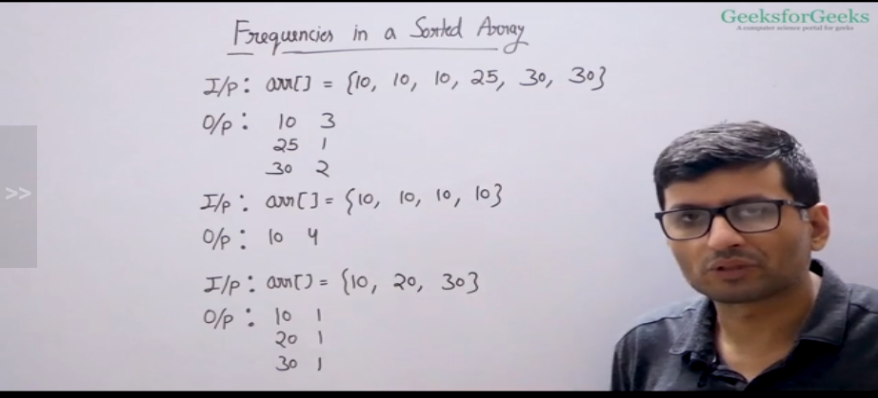

Time complexity of sol is theta(n)

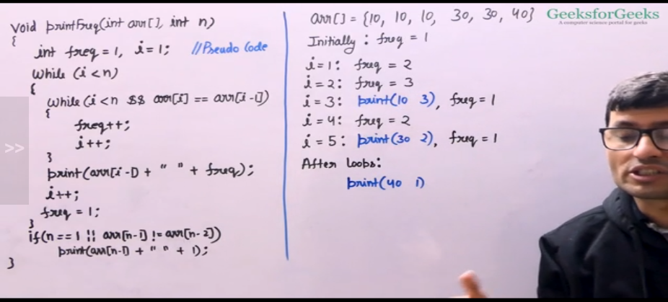

Stock buy and sell: To find the max gain b/w the buy and sell. In sorted array of decreasing values, there will not be any profit. For increasing values, profit will be diff b/w last element and first element

Naive sol:

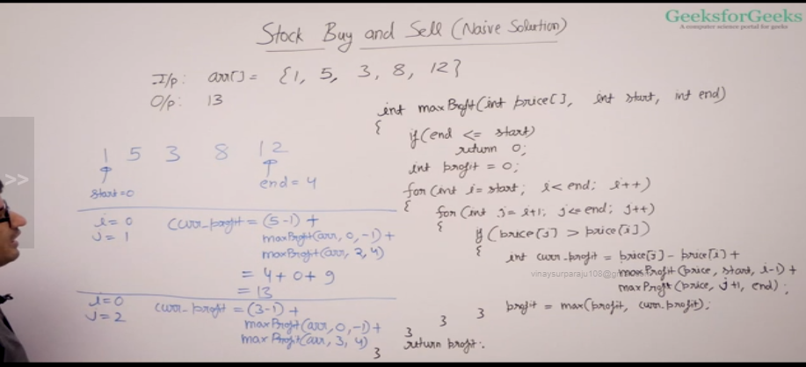

Eff sol:

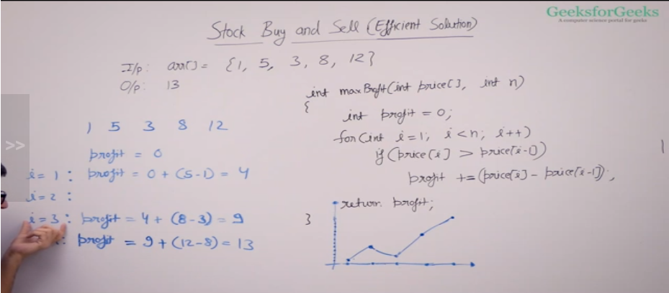

Trapping rain water:

Array will have non zero values. The value of each array is the height of bar’s.Find the unit of water to be collected

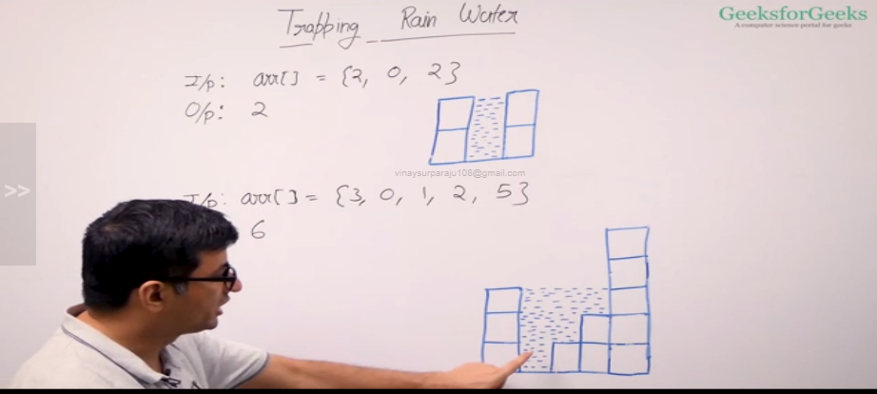

If the array is sorted in decreasing or increasing order, the amount of water collected is zero

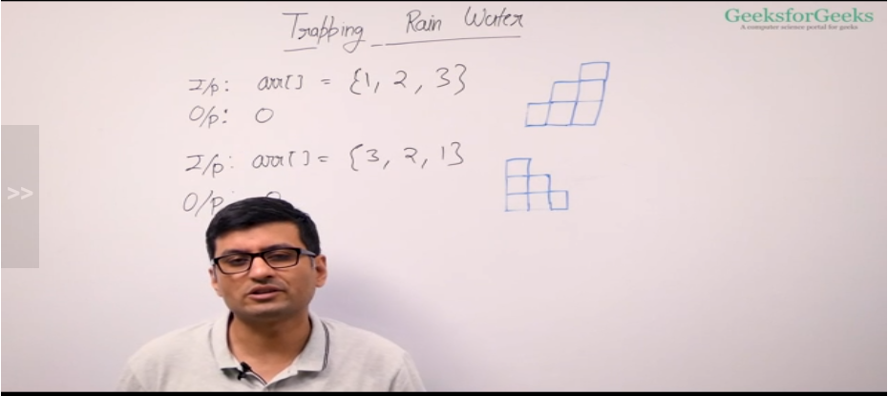

Naive sol: Time comp is theta(n^2)

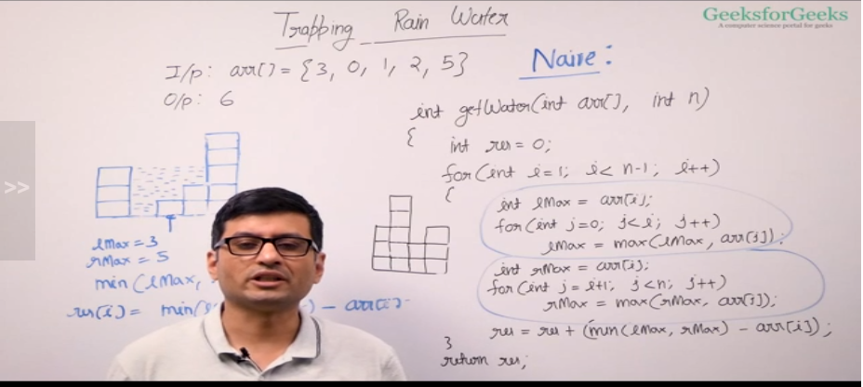

Eff sol: Time comp is theta(n)

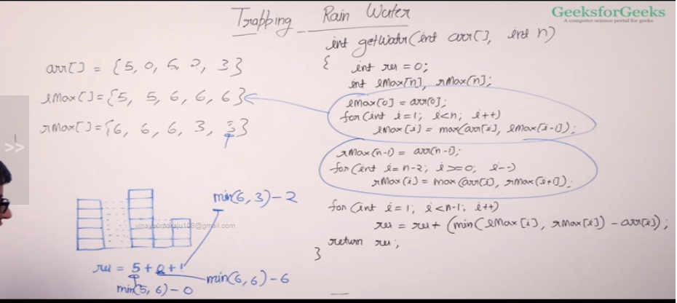

Maximum consecutive 1’s in binary array:

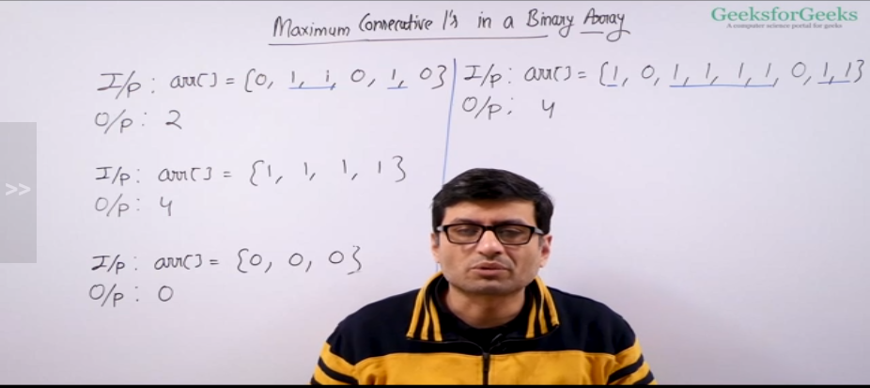

Naive app:

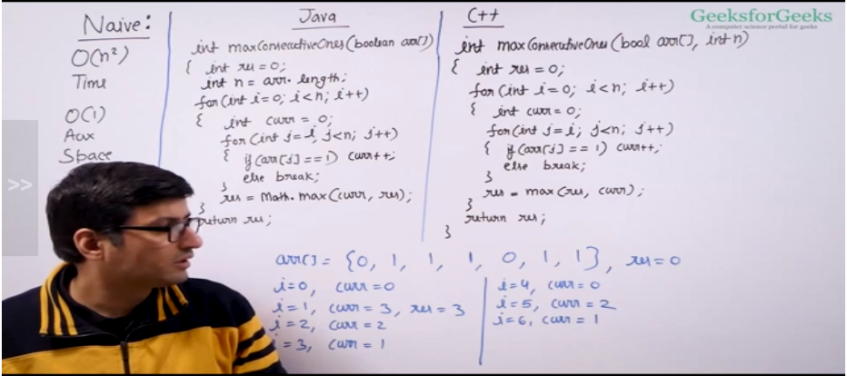

Eff app:

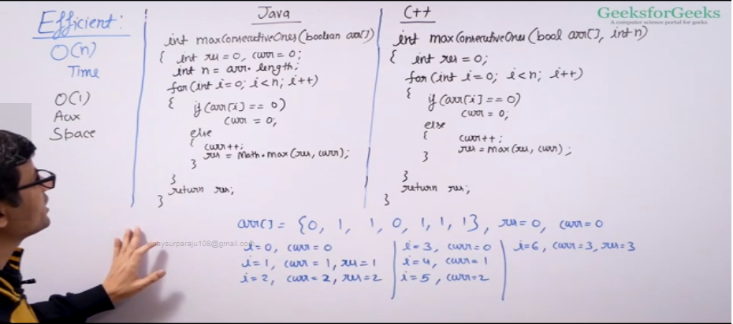

Max sum of subarray:

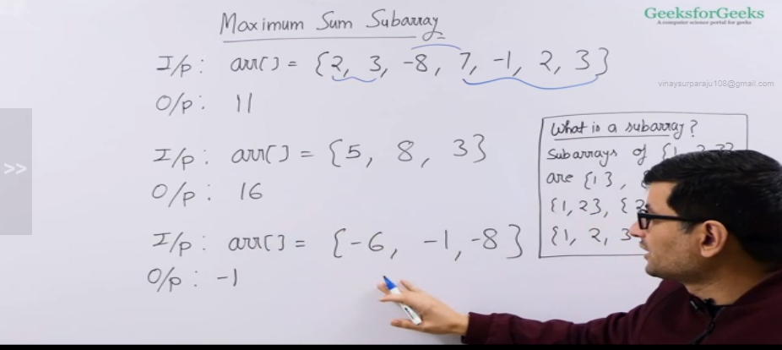

Naive app:

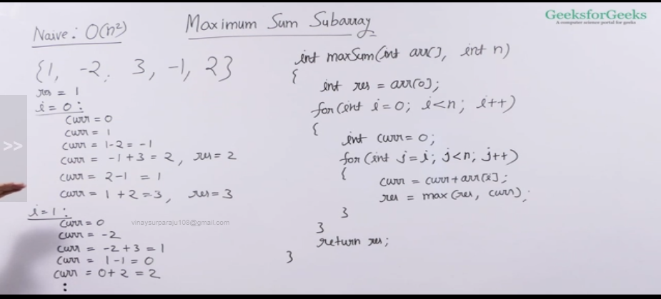

Eff app: Kadane’s algorithm

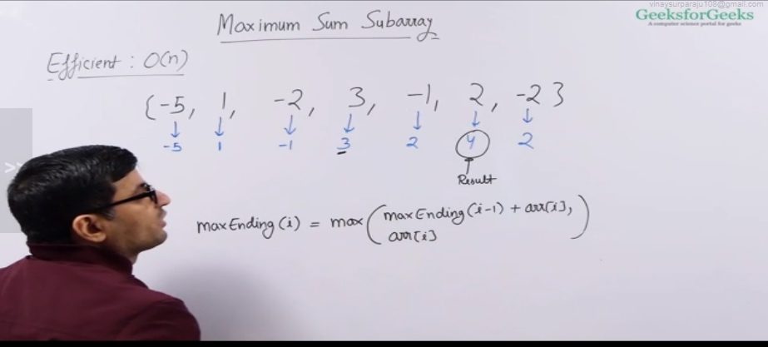

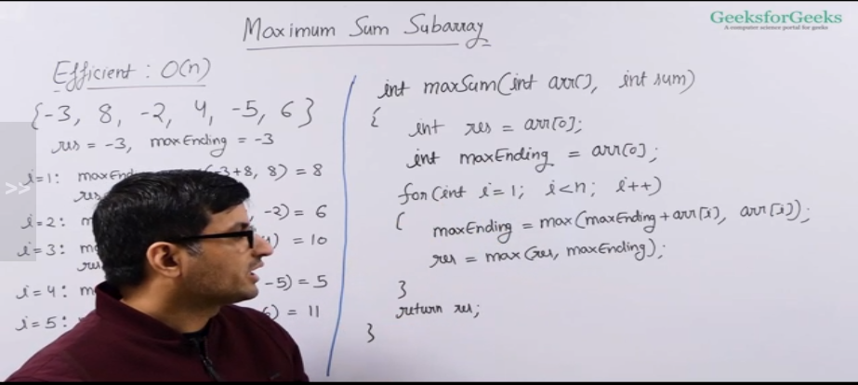

Longest length even odd subarray:

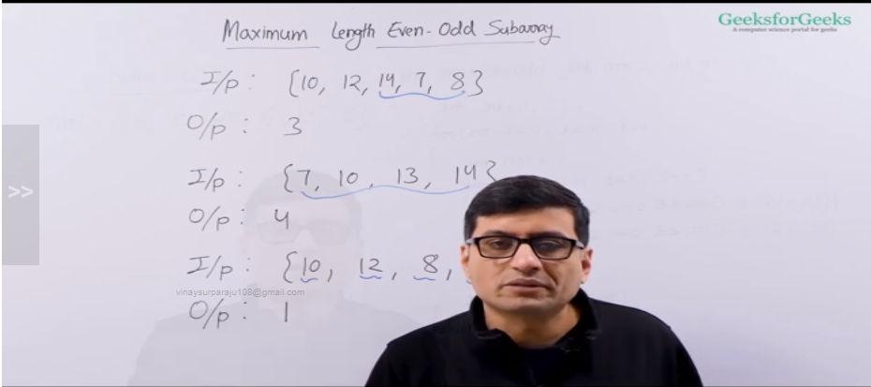

Naive app:

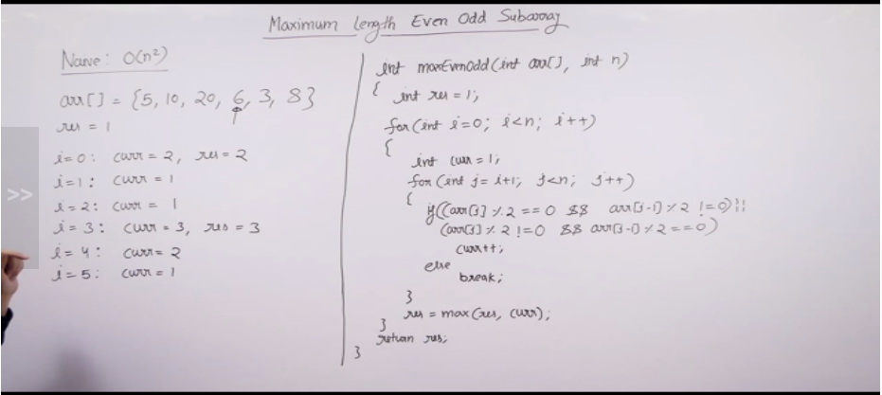

Eff app:

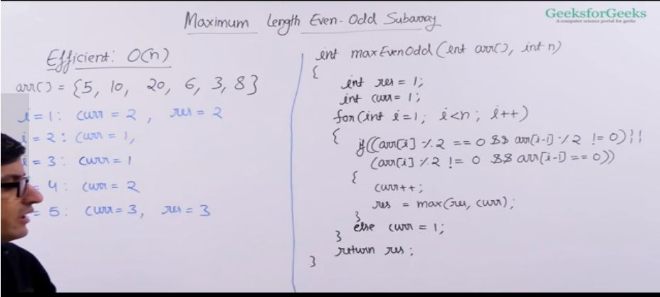

Max circular sub-array sum:

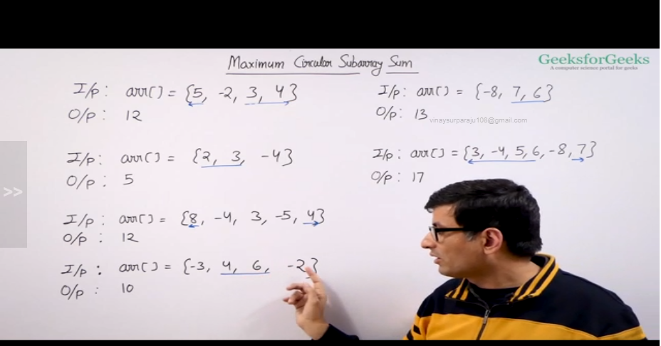

Naive app:

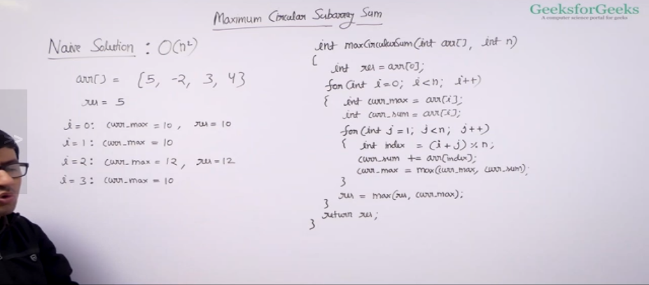

Eff app:

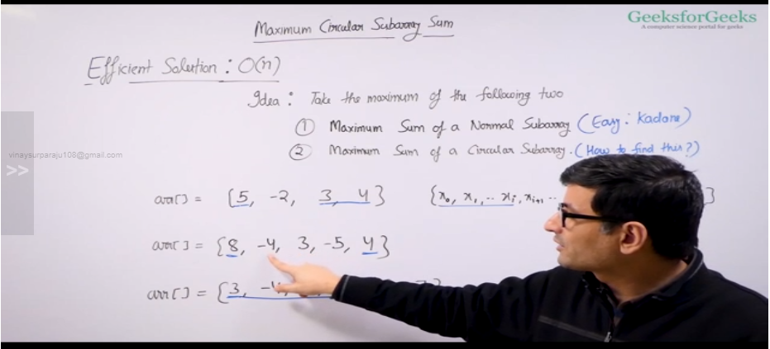

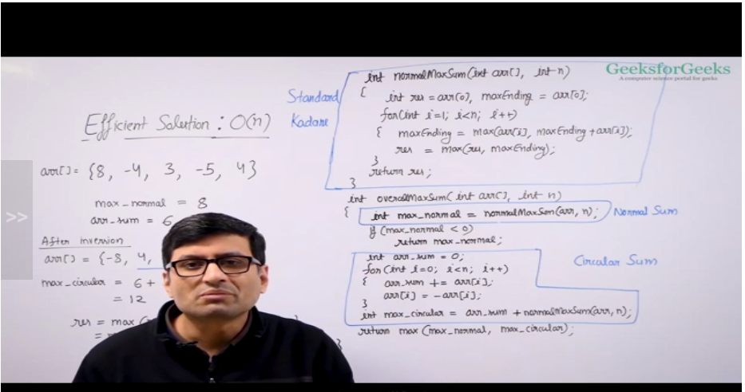

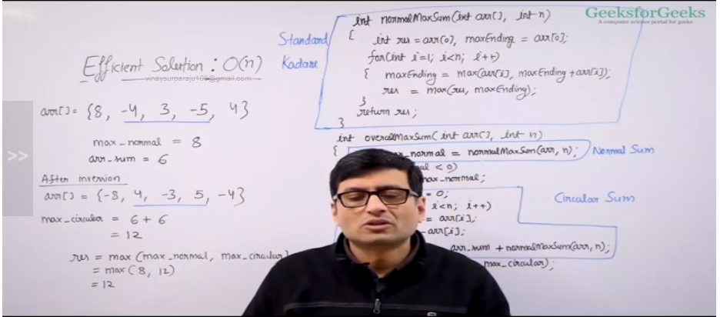

Majority element in array: Element which appears more than n/2 times

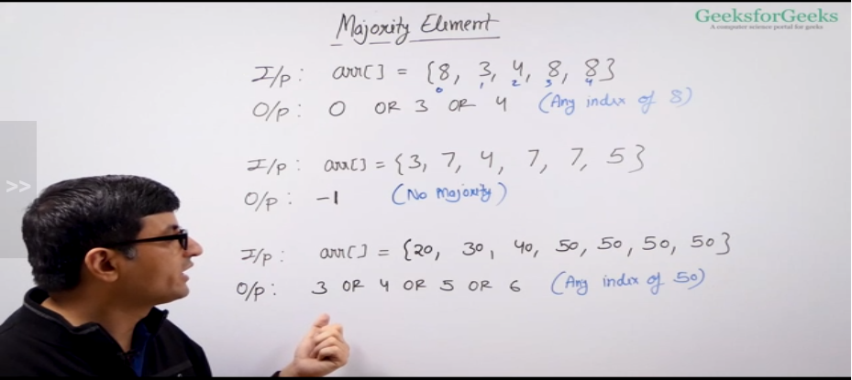

Naive app:

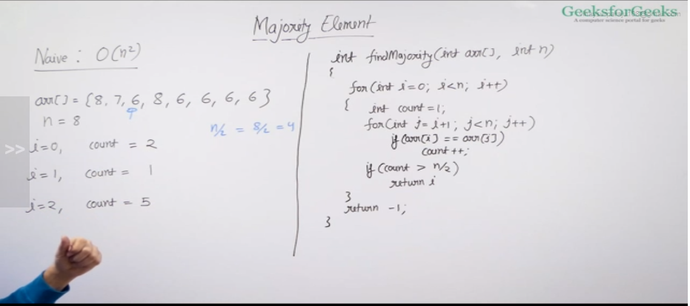

Eff app: Moores voting algorithm

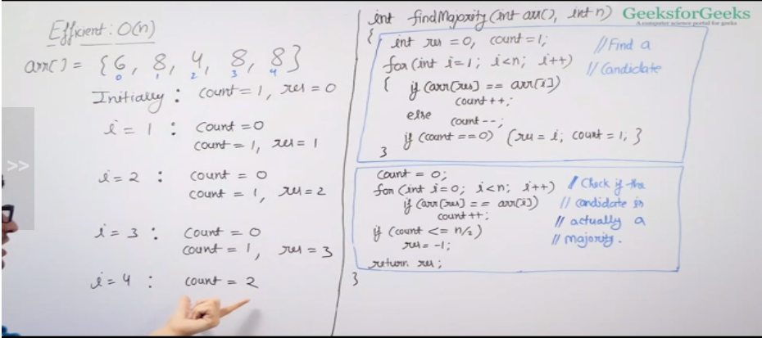

Minimum consecutive flips:

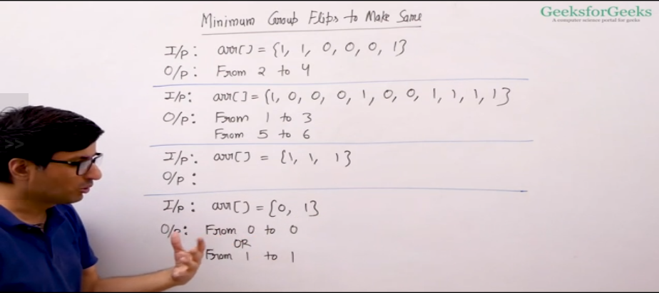

Always flip the second group, bcoz count will always be equal or less than other group

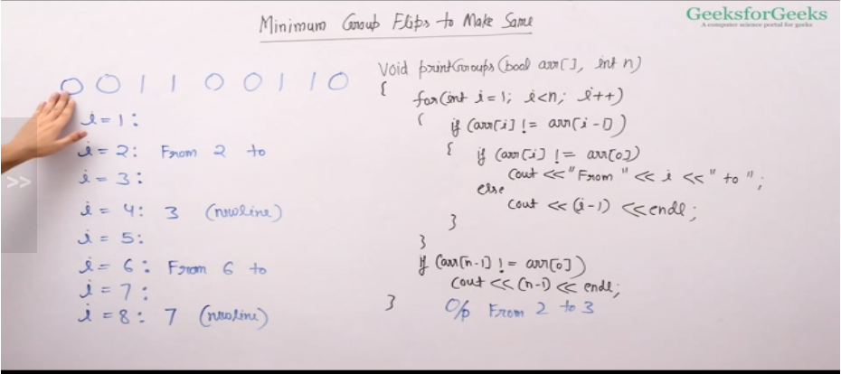

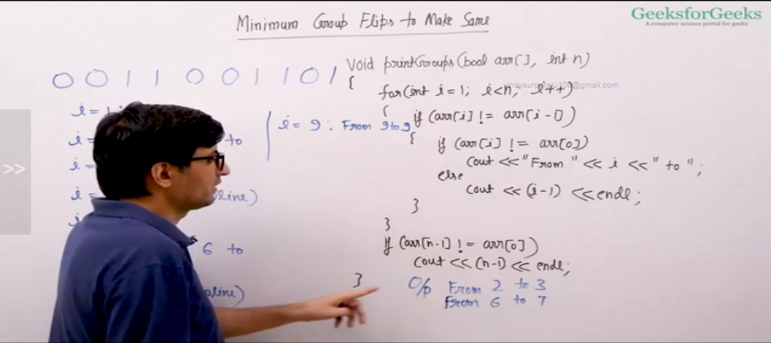

Window sliding technique:

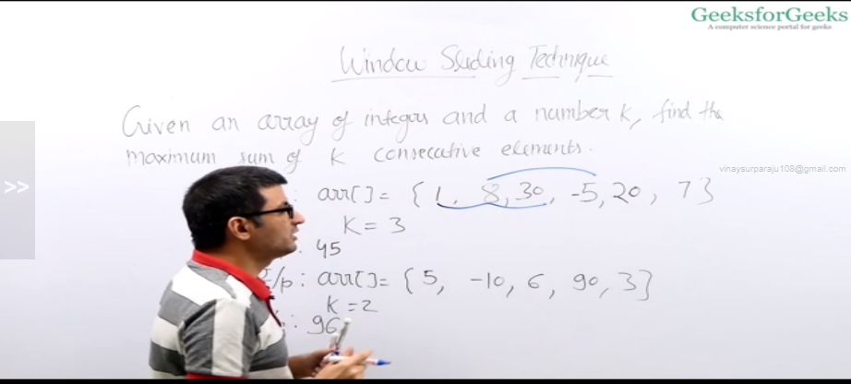

Naive sol:

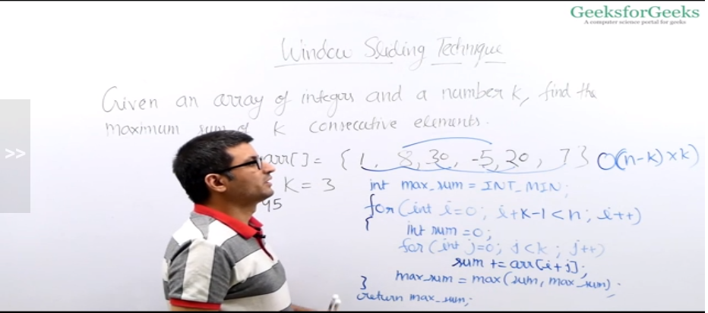

Eff sol:

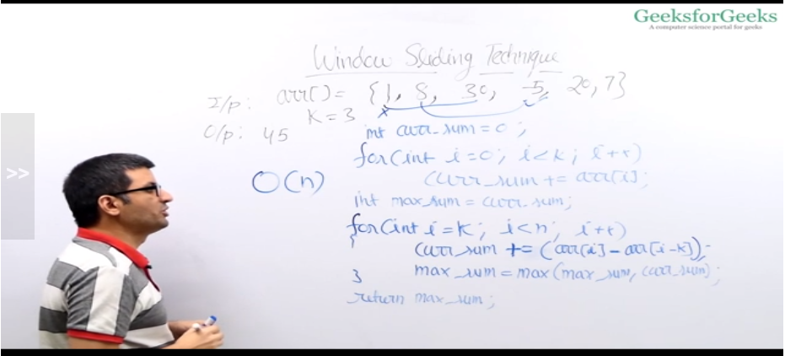

To check if the subarray sum is equal to the given sum

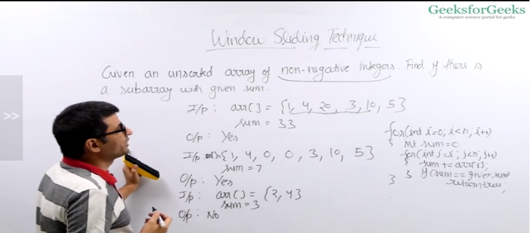

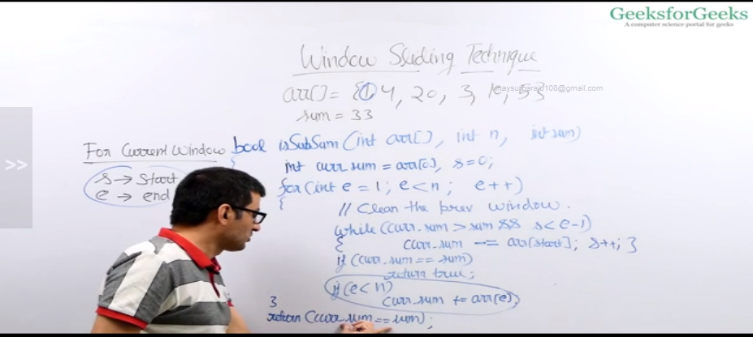

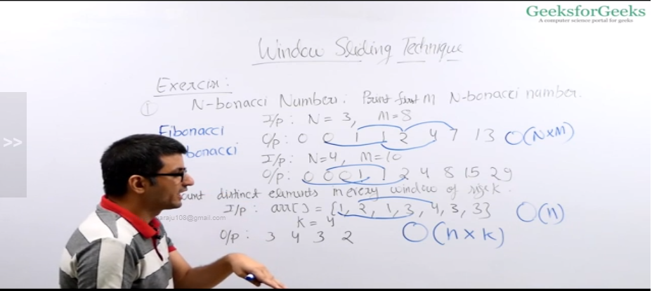

Prefix sum technique:

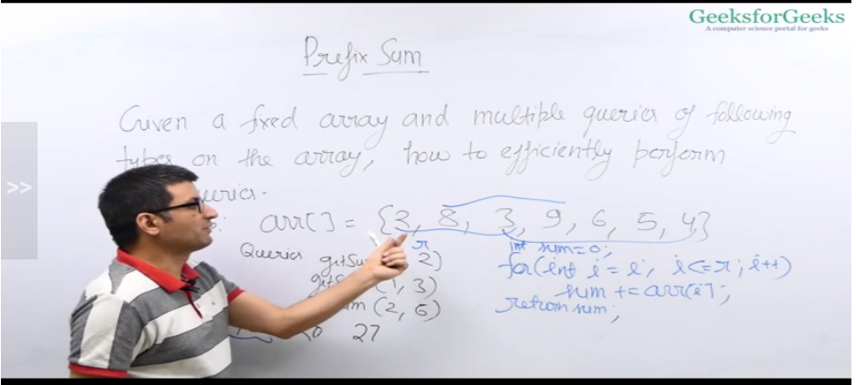

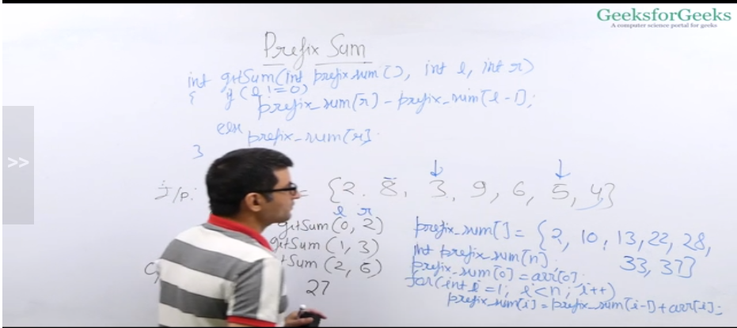

To find equilibrium point in the given array:

Naive:

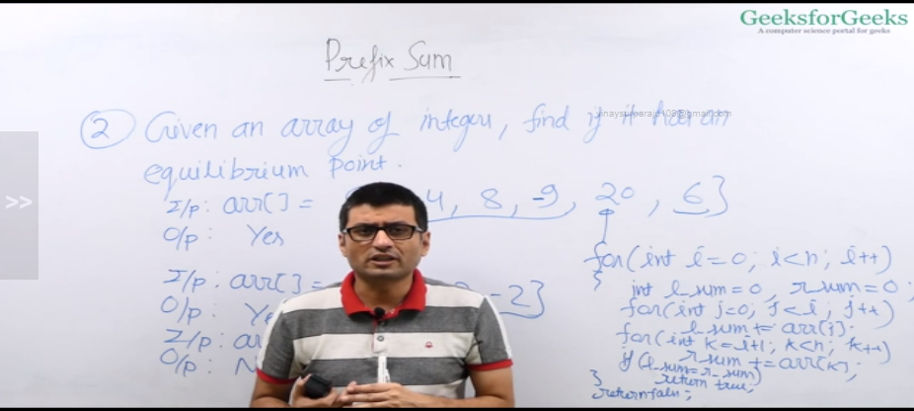

Eff app:

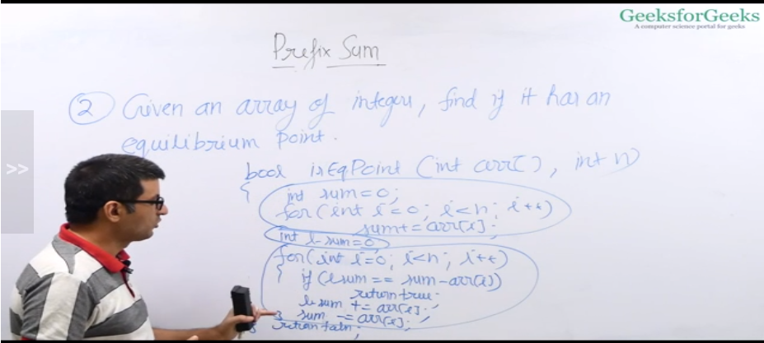

Find the max appearing element:

